Technical Design Document

# Microservices

Watchtime is a piece of enterprise software, therefore it requires an architecture that supports enterprise software.

For this project I have chosen to go with Microservices since they offer a lot of advantages when it comes to coding:

* Multiple technologies can be used.
* It is easily scalable by duplication, therefore low effort for big rewards.
* It is easy to replace existing parts.
* It follows security by design principles.

# Event Bus

The choices that I have for communication are API gateways, Messaging buses or Event buses.

I went with event buses mainly because I have already used API gateways for microservice communication before, and messaging buses sound boring because they the result is nearly the same as an API.

# User Stories

|  |  |  |
| --- | --- | --- |
| **As a(n):** | **I want to:** | **So that:** |
| User | Create an account | I can access the website’s functionality. |
| User | Customize my experience | I don’t have to see content I don’t like |
| User | Be able to watch videos | I can be entertained |
| User | Be able to pause videos | I can take a break |
| User | Be able to rate videos | I can express my opinion |
| User | Be able to change my rating on videos | I can express my change in opinion |
| User | Be able to comment | I can express my opinion |
| User | Be able to reply to comments | I can engage in discussions |
| User | Be able to report videos | I can help remove toxic content |
| User | Be able to become a content creator | I can post my videos |
| User | Be able to search by tags | I can find what interests me |

Content Creator (CC)

|  |  |  |
| --- | --- | --- |
| **As a(n):** | **I want to:** | **So that:** |
| CC | Be able to upload my videos | I can showcase my work |
| CC | Be able to view the ratings on my videos | I can know which videos do well and which don’t |
| CC | Be able to delete/hide my videos | I can remove my own videos that I do not like |
| CC | Be able to make Tickets | I can contact the admin team regarding help |

Admin

|  |  |  |
| --- | --- | --- |
| **As a(n):** | **I want to:** | **So that:** |
| Admin | Be able to view and reply to tickets | I can help users |
| Admin | Be able to remove toxic videos | I can keep a toxic-free environment |
| Admin | Be able to ban users | I can remove toxic users |

Outside Company (OC)

|  |  |  |
| --- | --- | --- |
| **As a(n):** | **I want to:** | **So that:** |
| OC | Be able to copyright videos due to copyright issues. | I can keep my Intellectual Propriety safe |

# Figures

Figure 1 showcases the global architecture

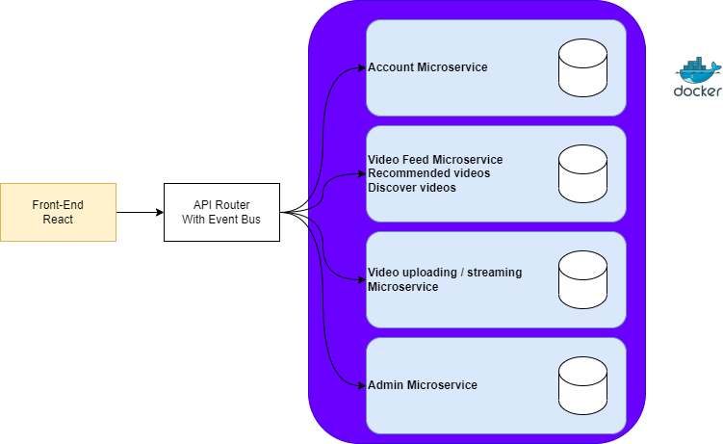

Figure 1

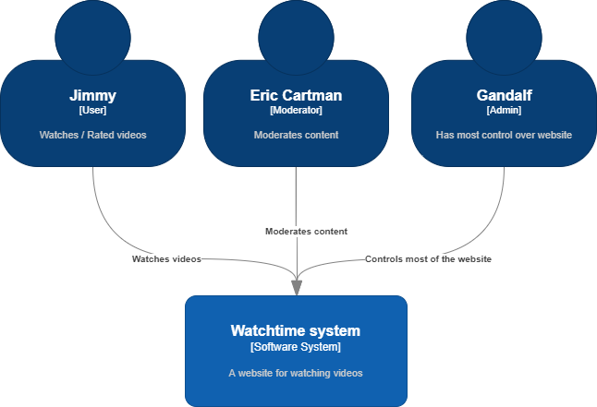Figure 2 showcases the highest level of the C4 diagram

Figure

Figure 3 showcases the mid level of a C4 diagram

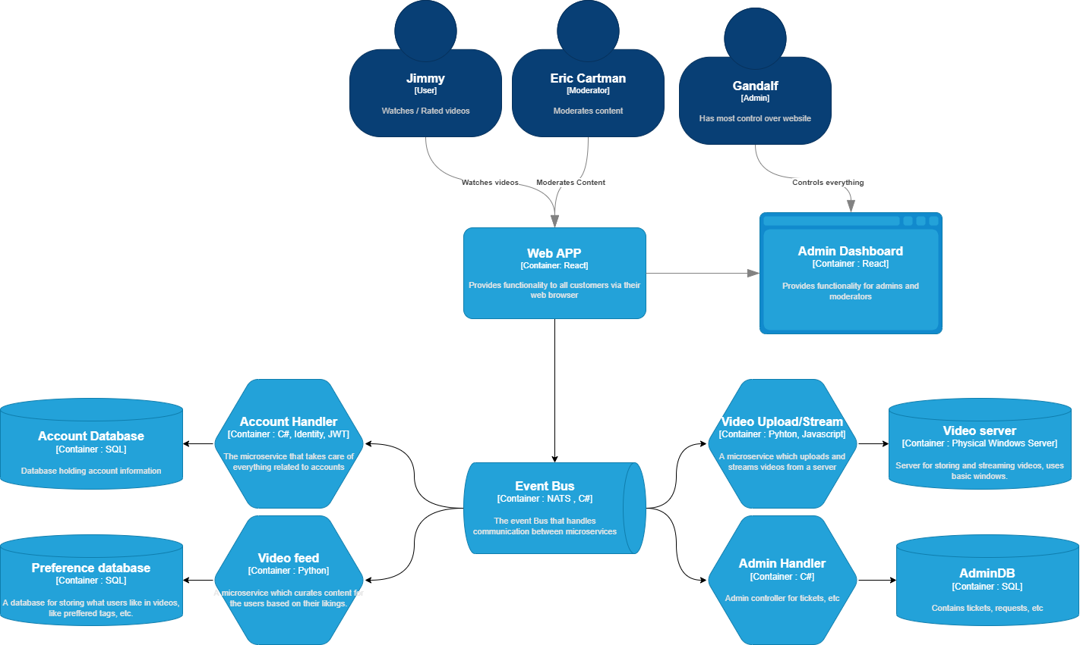

Figure 3